TRƯỜNG ĐẠI HỌC KHOA HỌC TỰ NHIÊN

**KHOA CÔNG NGHỆ THÔNG TIN**

**Trần Hoàng Quân – 19120338**

**Sử Nhật Đăng – 19120469**

**Trần Cẩm Khánh – 19120542**

**Nguyễn Thị Kim Ngân – 19120598**

**Lê Hoàng Trọng Tín – 19120682**

**BÁO CÁO ĐỒ ÁN NHÓM 13**

**ĐỀ TÀI BÁN VÉ CHUYẾN BAY**

MÔN HỌC NHẬP MÔN CÔNG NGHỆ PHẦN MỀM

CHƯƠNG TRÌNH CHÍNH QUY

**GIÁO VIÊN LÝ THUYẾT**

Th.S. Bùi Tấn Lộc

**GIÁO VIÊN HƯỚNG DẪN THỰC HÀNH**

Th.S. Nguyễn Thành An

Tp. Hồ Chí Minh, tháng 5/2022

**Mục lục**

Mục lục 2

Danh sách các hình 5

Danh sách các bảng 1

Chương 2 Requirement Analysis 2

**2.1 Wireframe** 2

**2.2 Data Flow Diagram** 5

**2.3** **Data Modeling** 17

2.3.1 CRC Modeling 17

2.3.2 Conceptual ERD 21

2.3.3 Logical ERD 22

**2.4** **Architectural Analysis** 23

2.4.1 Analysis Architecture 23

2.4.1.1 High Level Abstract Architecture - Level 0 23

2.4.1.2 High Level Abstract Architecture - Level 1 24

2.4.2 Analysis Package 24

2.4.2.1 High Level Abstract Analysis Package - Level 0 24

2.4.2.2 High Level Abstract Analysis Package - Level 1 25

**2.5** **VOPC Analysis** 27

2.5.1 Sequence Diagram for Booking Flight Use Case 27

2.5.1.1 Analysis Class cho Booking Flight Use Case 27

2.5.1.2 Analysis Package cho Booking Flight Use Case 27

2.5.2 Sequence Diagram for Create Flight Use Case 28

2.5.2.1 Analysis Class cho Create Flight Use Case 28

2.5.2.2 Analysis Package cho Create Flight Use Case 29

2.5.3 Sequence Diagram for Update Flight Use Case 29

2.5.3.1 Analysis Class cho Update Flight Use Case 29

2.5.3.2 Analysis Package cho Update Flight Use Case 29

2.5.4 Sequence Diagram for Create Report 30

2.5.4.1 Analysis Class for Create Report 30

2.5.4.2 Analysis Package for Creating Report 31

2.5.5 Sequence Diagram for Create Account 31

2.5.5.1 Analysis Class for Create Account 31

2.5.5.2 Analysis Package for Create Account 32

2.5.6 Sequence Diagram for Update Account 32

2.5.6.1 Analysis Class for Update Account 33

2.5.6.2 Analysis Package for Update Account 33

2.5.7 Read Flight List 34

2.5.7.1 Analysis Class for Read Flight List 34

2.5.7.2 Analysis Package for Read Flight List 35

2.5.8 Read Flight Detail 36

2.5.8.1 Class dỉagram for Read Flight Detail 37

2.5.8.2 Package diagram for Read Flight Detail 38

2.5.9 Sequence Diagram for Read Account List 38

2.5.9.1 Analysis Class for Read Account List 39

2.5.9.2 Analysis Package for Read Account List 39

2.5.10 Sequence Diagram for Read Account Detail 40

2.5.10.1 Analysis Class for Read Account Detail 40

2.5.10.2 Analysis Package for Read Account Detail 41

2.5.11 Sequence Diagram for Login 41

2.5.11.1 Analysis Class for Login 42

2.5.11.2 Analysis Package for Login 42

2.5.12 Sign Up Sequence Diagram 43

2.5.12.1 Analysis Class for Sign Up 43

2.5.12.2 Analysis Package for Sign Up 44

**2.6** **4 + 1 Architectural View Modeling in Analysis Level** 44

2.6.1 Process / Behavior View 44

2.6.1.1 Sequence Diagram 44

2.6.2 Implementation / Developer View 50

2.6.2.1 Package Diagram 50

2.6.3 Logical / Structural View 51

2.6.3.1 Class Diagram 51

2.6.4 Deployment / Physical View 52

2.6.4.1 Deployment Diagram 52

**Danh sách các hình**

**Hình 2.1: Wireframe màn hình tạo tài khoản mới của Admin** 2

**Hình 2.2: Wireframe màn hình tạo chuyến bay** 2

**Hình 2.3: Wireframe màn hình Xem danh sách tài khoản.** 3

**Hình 2.4: Wireframe xem danh sách chuyến bay (khách hàng)** 3

**Hình 2.5: Wireframe màn hình xem chi tiết chuyến bay** 4

**Hình 2.6: Sơ đồ DFD tổng quát cho màn hình Đăng ký tài khoản** 5

**Hình 2.7: Sơ đồ DFD tổng quát cho màn hình Đăng nhập tài khoản** 6

**Hình 2.8: Sơ đồ DFD tổng quát cho màn hình Đặt vé chuyến bay** 7

**Hình 2.9: Sơ đồ DFD tổng quát cho màn hình Tạo chuyến bay** 8

**Hình 2.10: Sơ đồ DFD tổng quát cho màn hình Cập nhật thông tin chuyến bay** 9

**Hình 2.11: Sơ đồ DFD tổng quát cho màn hình Tạo báo cáo theo tháng** 10

**Hình 2.12: Sơ đồ DFD tổng quát cho màn hình Create Account** 11

**Hình 2.13: Sơ đồ DFD tổng quát cho màn hình Update Account** 12

**Hình 2.14: Sơ đồ DFD tổng quát cho màn hình Xem danh sách tài khoản** 13

**Hình 2.15: Sơ đồ DFD tổng quát cho màn hình Xem chi tiết tài khoản** 14

**Hình 2.16: Sơ đồ DFD tổng quát cho màn hình Xem danh sách chuyến bay** 15

**Hình 2.17: Sơ đồ DFD tổng quát cho màn hình Xem chi tiết chuyến bay** 16

**Hình 2.18: Phiên bản first-cut class diagram** 21

**Hình 2.19: Phiên bản first-cut ERD** 21

**Hình 2.20: Concept ERD** 22

**Hình 2.21: Logical ERD** 23

**Hình 2.22: Kiến trúc tổng quát 3-Tier** 24

**Hình 2.23: Architecture cho data fault analysis system** 24

**Hình 2.24: VC Structure ở mức Abstract level 0** 25

**Hình 2.25: MVC Structure ở mức Abstract level 1** 27

**Hình 2.26: Booking Flight sequence diagram** 27

**Hình 2.27: Class Diagram cho Booking Flight Use Case** 27

**Hình 2.28: Analysis Package cho Booking Flight Use Case** 28

**Hình 2.29: Create Flight sequence diagram** 28

**Hình 2.30: Class Diagram cho Create Flight Use Case** 28

**Hình 2.31: Analysis Package cho Create Flight Use Case** 29

**Hình 2.32: Update Flight sequence diagram** 29

**Hình 2.33: Class Diagram cho Update Flight Use Case** 29

**Hình 2.34: Analysis Package cho Update Flight Use Case** 30

**Hình 2.35: Create Report sequence diagram** 30

**Hình 2.36: Class Diagram cho Create Report Use Case** 30

**Hình 2.37: Analysis Package cho Create Report Use Case** 31

**Hình 2.38: Create Account sequence diagram** 31

**Hình 2.39: Class Diagram cho Create Account Use Case** 32

**Hình 2.40: Analysis Package cho Create Account Use Case** 32

**Hình 2.41: Update Account sequence diagram** 32

**Hình 2.42: Class Diagram cho Update Account Use Case** 33

**Hình 2.43: Analysis Package cho Update Account Use Case** 33

**Hình 2.44: Read Flight List sequence diagram** 34

**Hình 2.45: Class Diagram cho Read Flight List Use Case** 35

**Hình 2.46: Analysis Package cho Read Flight List Use Case** 35

**Hình 2.47: Read Flight Detail sequence diagram** 36

**Hình 2.48: Class Diagram cho Read Flight Detail Use Case** 37

**Hình 2.49: Analysis Package cho Read Flight Detail Use Case** 38

**Hình 2.50: Read Account List sequence diagram** 39

**Hình 2.51: Analysis Class cho Read Account List Use Case** 39

**Hình 2.52: Analysis Package cho Read Account List Use Case** 39

**Hình 2.53: Read Account Detail sequence diagram** 40

**Hình 2.54: Analysis Class cho Read Account Detail Use Case** 40

**Hình 2.55: Analysis Package cho Read Account Detail Use Case** 41

**Hình 2.56: Login sequence diagram** 41

**Hình 2.57: Analysis Class cho Login Use Case** 42

**Hình 2.58: Analysis Package cho Login Use Case** 42

**Hình 2.59: Sign Up sequence diagram** 43

**Hình 2.60: Analysis Class cho Sign Up Use Case** 43

**Hình 2.61: Analysis Package cho Sign Up Use Case** 44

**Hình 2.62: Sequence Diagram for Booking Flight** 44

**Hình 2.63: Sequence Diagram for Create Flight** 45

**Hình 2.64: Sequence Diagram for Update Flight** 45

**Hình 2.65: Sequence Diagram for Create Report** 46

**Hình 2.66: Sequence Diagram for Create Account** 46

**Hình 2.67: Sequence Diagram for Update Account** 47

**Hình 2.68: Sequence Diagram for Read Flight List** 47

**Hình 2.69: Sequence Diagram for Read Flight Detail** 48

**Hình 2.70: Sequence Diagram for Read Account List** 48

**Hình 2.71: Sequence Diagram for Read Account Detail** 49

**Hình 2.72: Sequence Diagram for Login** 49

**Hình 2.73: Sequence Diagram for Sign Up** 50

**Hình 2.74: Package Diagram** 51

**Hình 2.75: Class Diagram** 52

**Hình 2.76: Deployment Diagram** 53

**Danh sách các bảng**

**Bảng 2.1: Initial User Roles** 17

# **Chương 2 Requirement Analysis**

## **2.1 Wireframe**

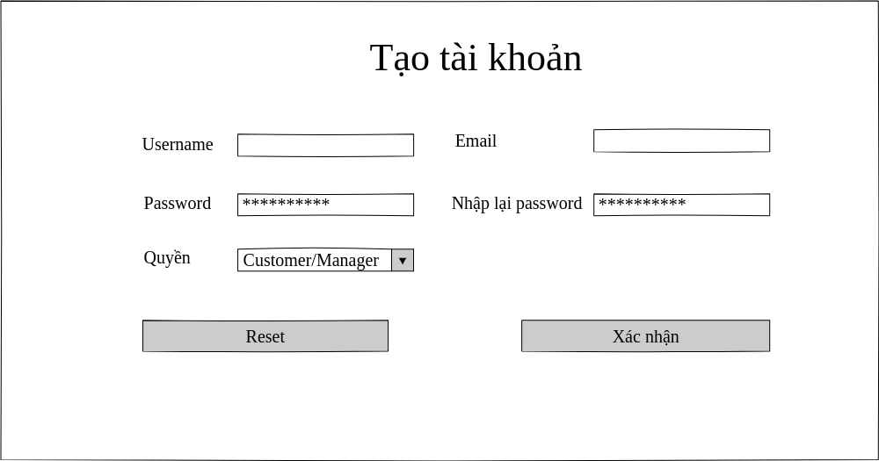

**Hình 2.1: Wireframe màn hình tạo tài khoản mới của Admin**

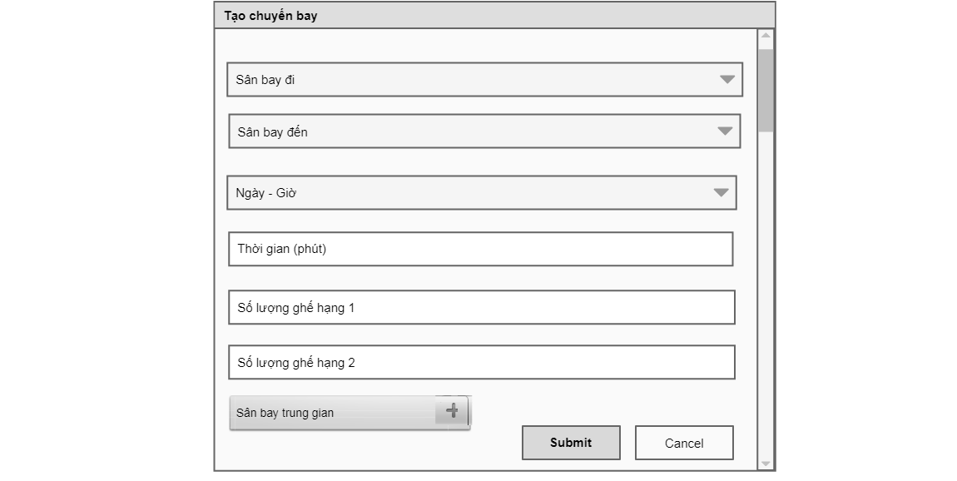

**Hình 2.2: Wireframe màn hình tạo chuyến bay**

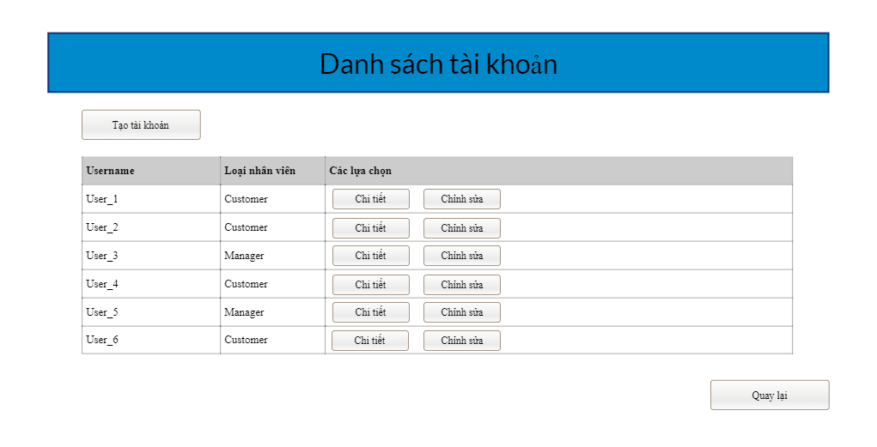

**Hình 2.3: Wireframe màn hình Xem danh sách tài khoản.**

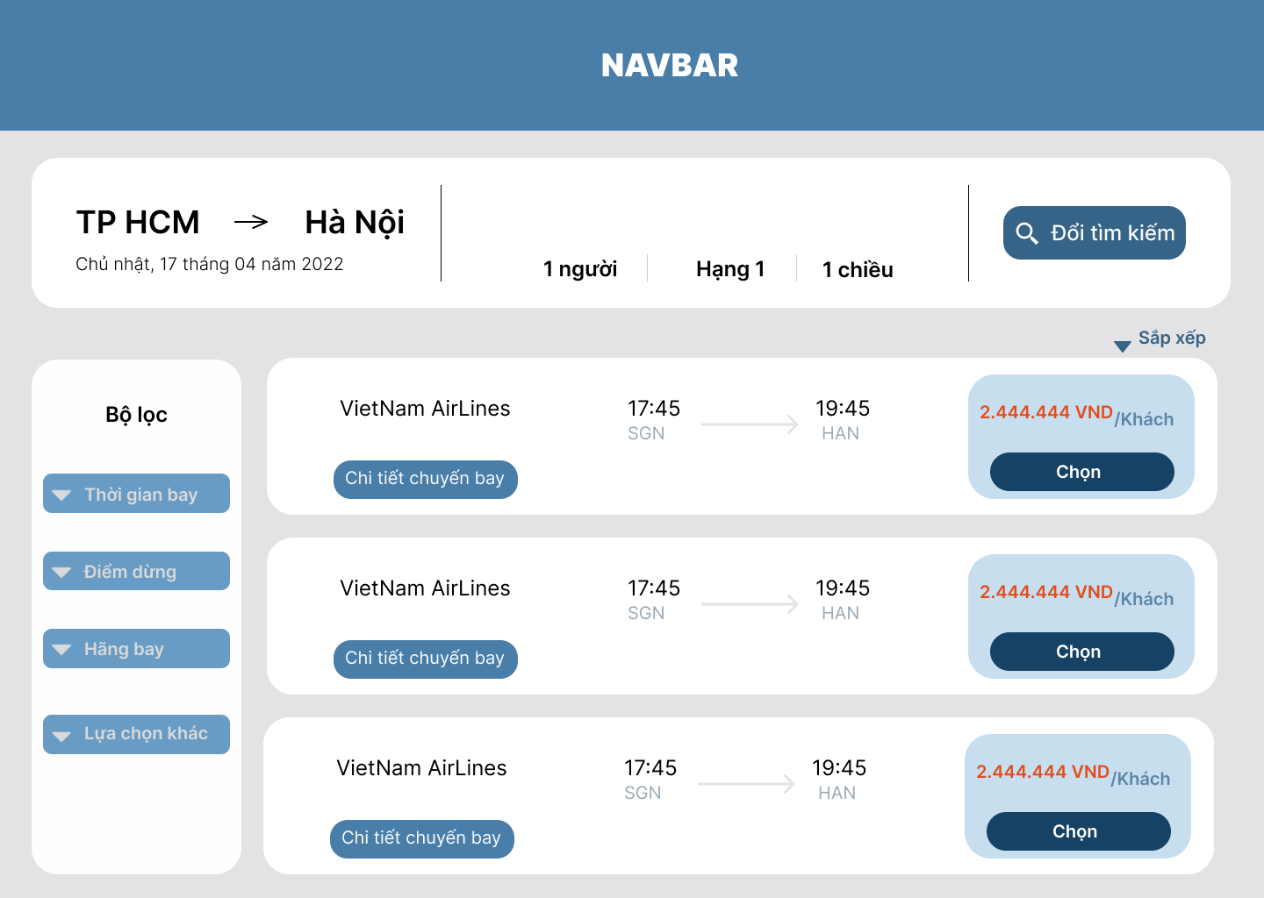

**Hình 2.4: Wireframe xem danh sách chuyến bay (khách hàng)**

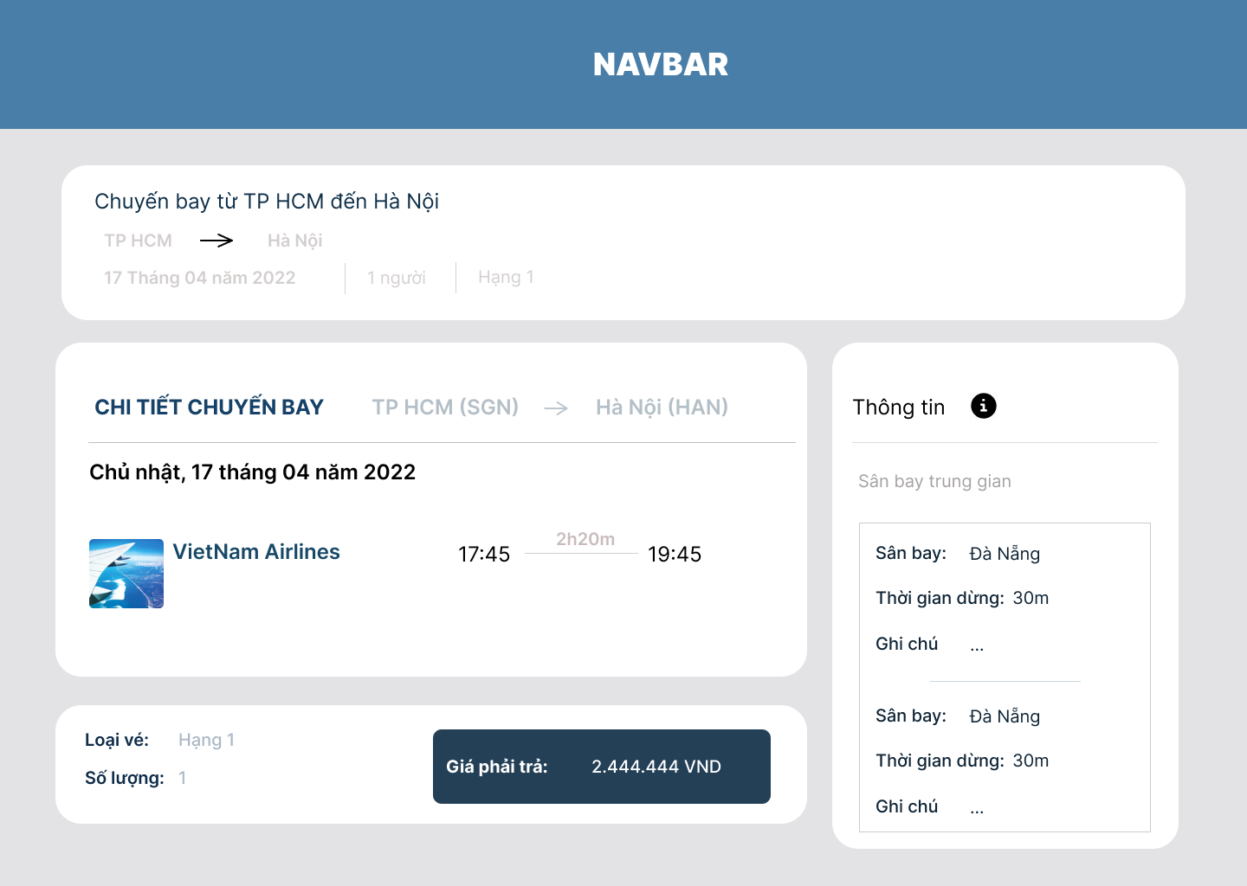

**Hình 2.5: Wireframe màn hình xem chi tiết chuyến bay**

## **2.2 Data Flow Diagram**

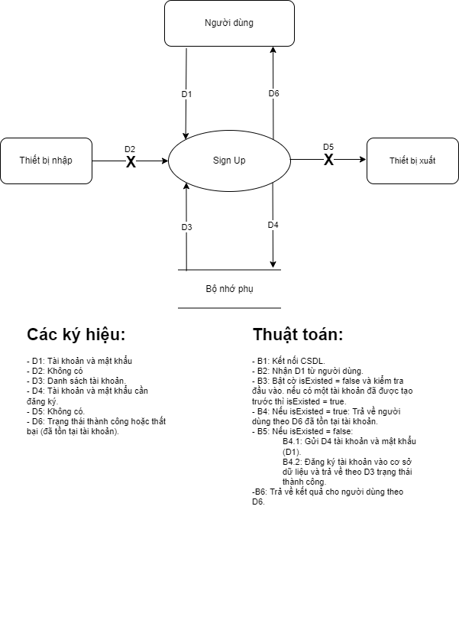

**Hình 2.6: Sơ đồ DFD tổng quát cho màn hình Đăng ký tài khoản**

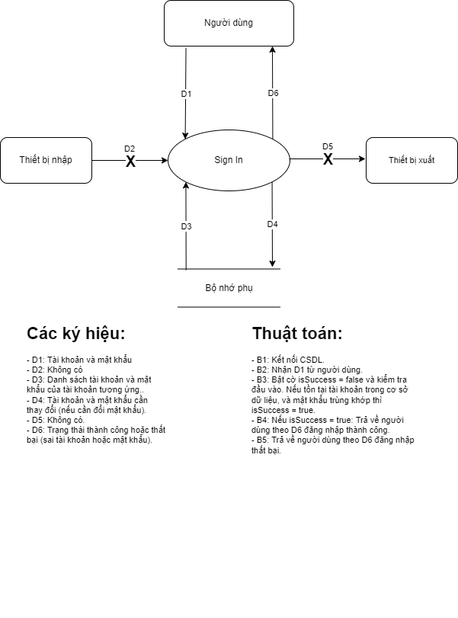

**Hình 2.7: Sơ đồ DFD tổng quát cho màn hình Đăng nhập tài khoản**

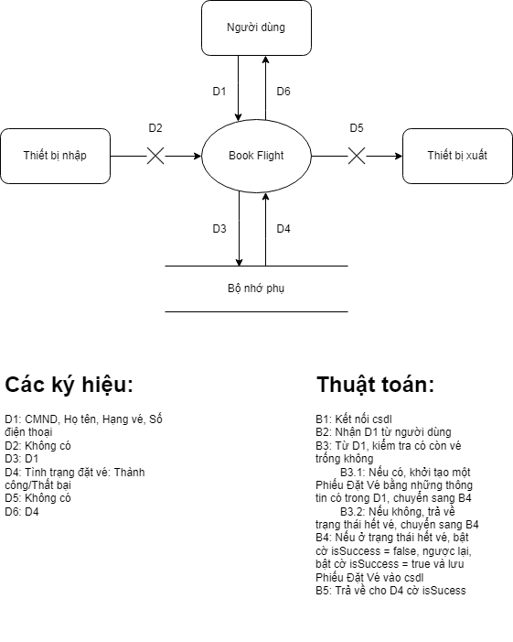

**Hình 2.8: Sơ đồ DFD tổng quát cho màn hình Đặt vé chuyến bay**

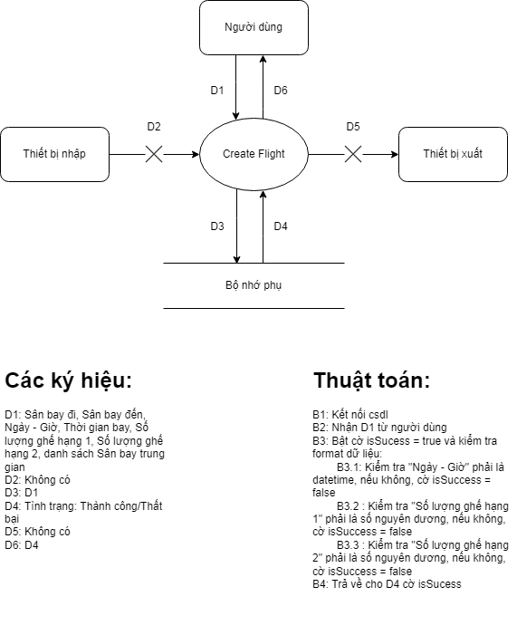

**Hình 2.9: Sơ đồ DFD tổng quát cho màn hình Tạo chuyến bay**

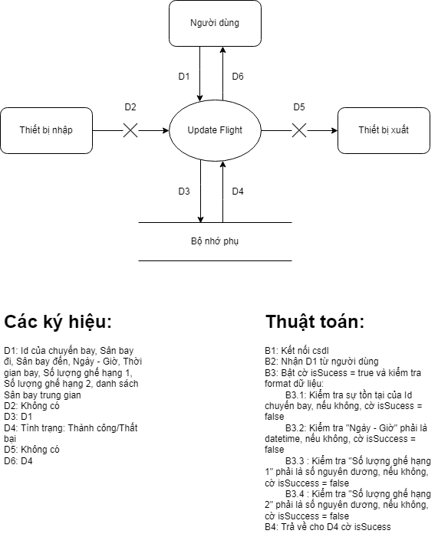

**Hình 2.10: Sơ đồ DFD tổng quát cho màn hình Cập nhật thông tin chuyến bay**

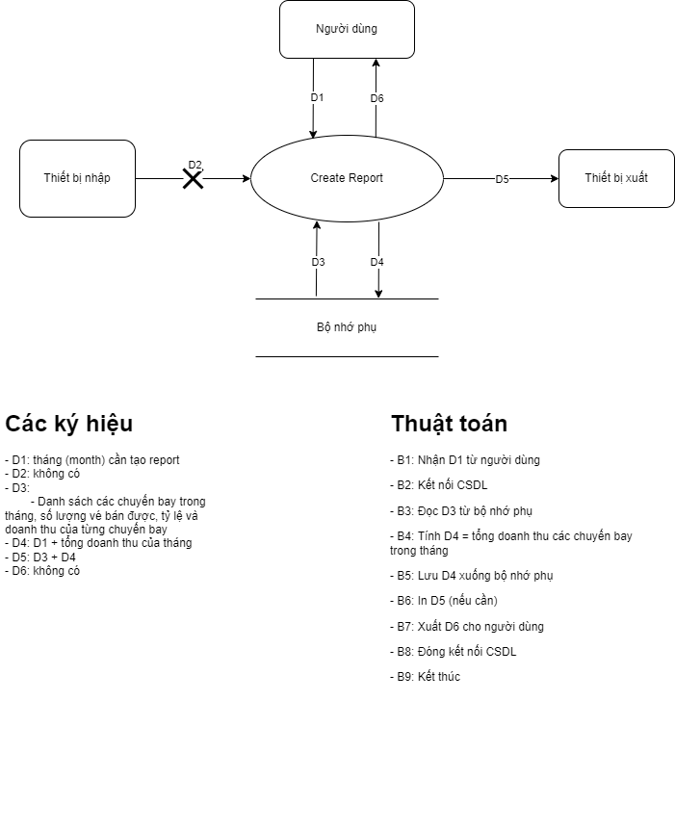

**Hình 2.11: Sơ đồ DFD tổng quát cho màn hình Tạo báo cáo theo tháng**

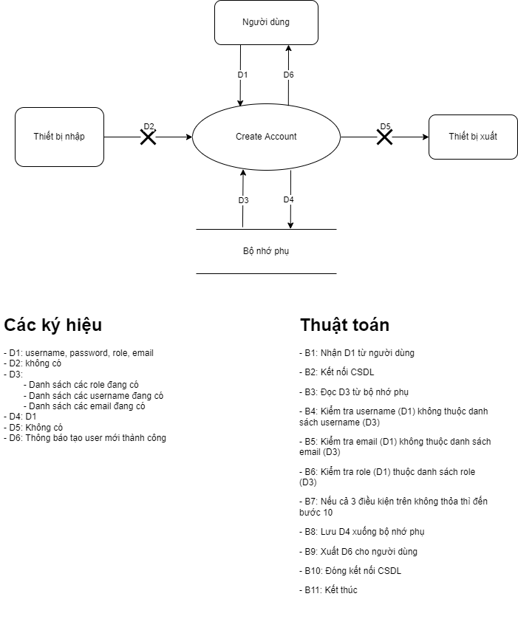

**Hình 2.12: Sơ đồ DFD tổng quát cho màn hình Create Account**

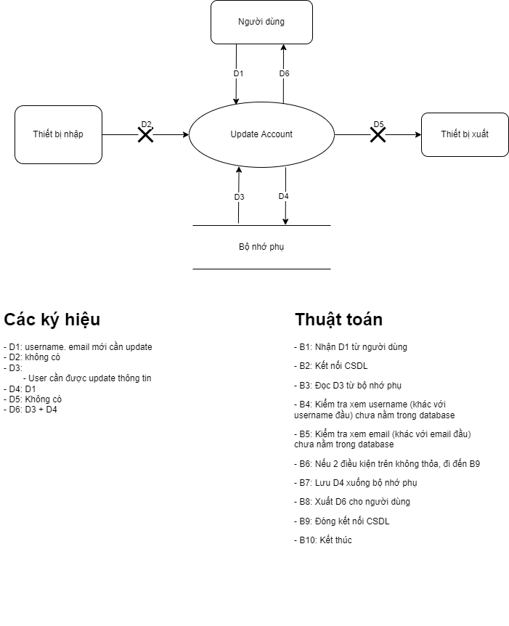

**Hình 2.13: Sơ đồ DFD tổng quát cho màn hình Update Account**

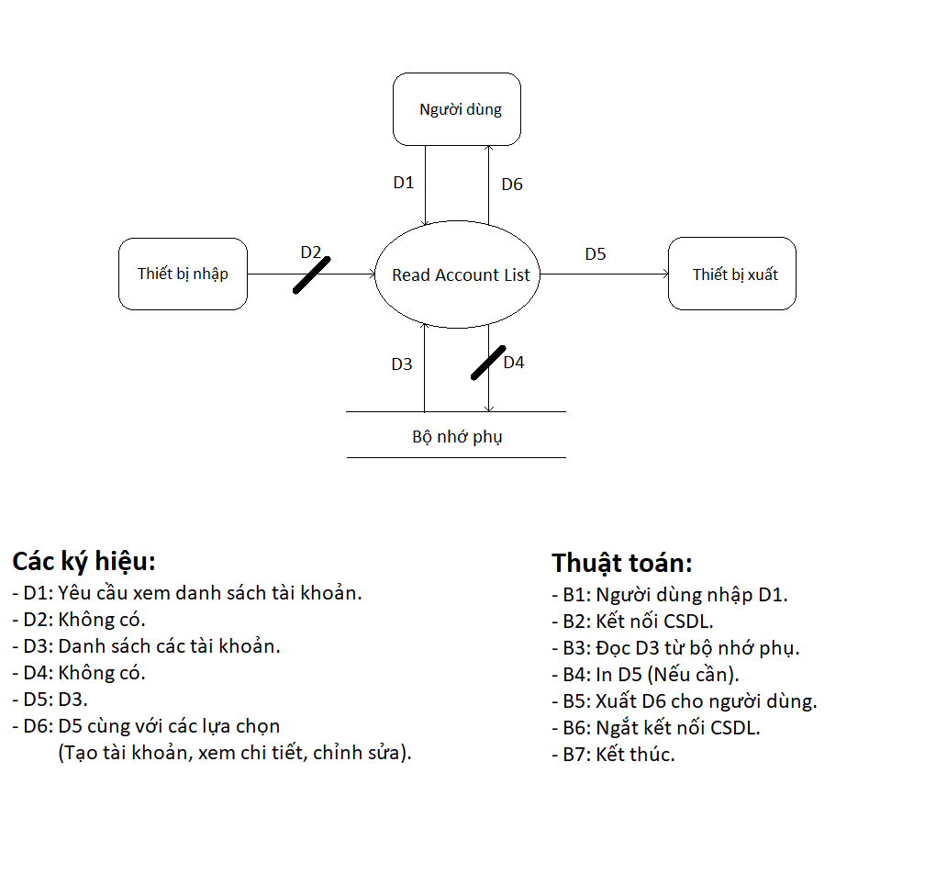

**Hình 2.14: Sơ đồ DFD tổng quát cho màn hình Xem danh sách tài khoản**

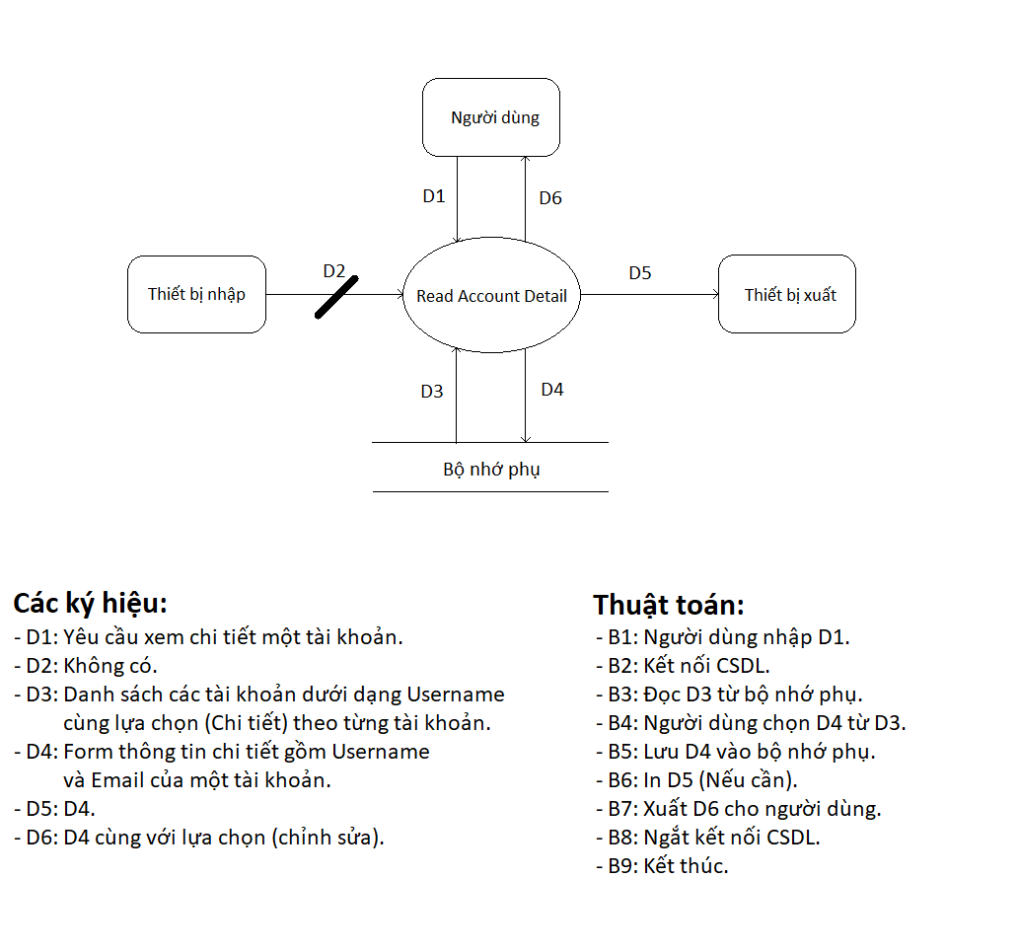

**Hình 2.15: Sơ đồ DFD tổng quát cho màn hình Xem chi tiết tài khoản**

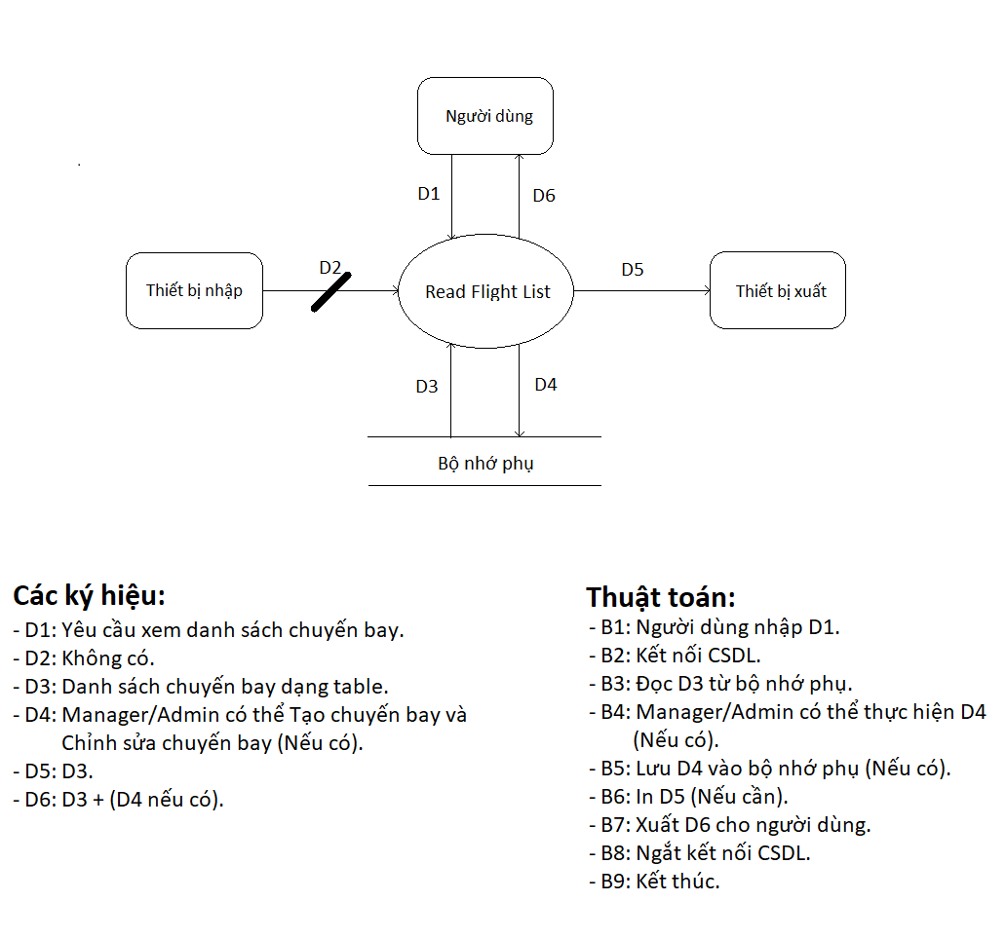

**Hình 2.16: Sơ đồ DFD tổng quát cho màn hình Xem danh sách chuyến bay**

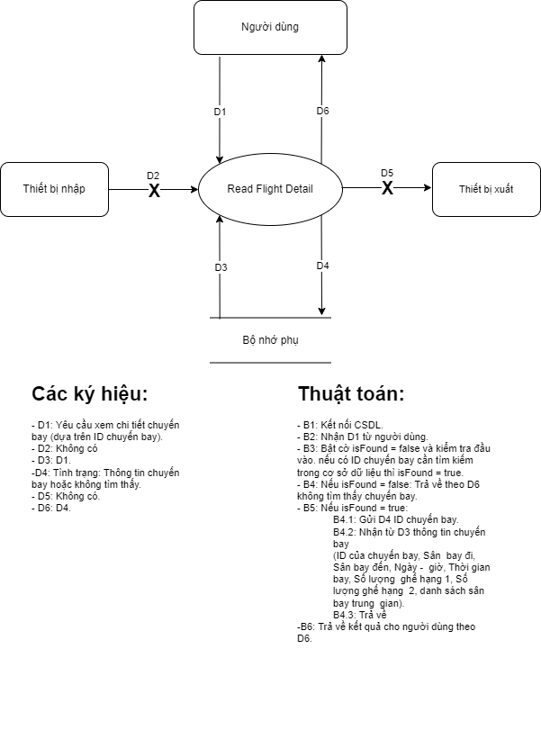

**Hình 2.17: Sơ đồ DFD tổng quát cho màn hình Xem chi tiết chuyến bay**

## **2.3** **Data Modeling**

### 2.3.1 CRC Modeling

**Bảng 2.1: Initial User Roles**

|  |  |  |
| --- | --- | --- |
| **Class** | **Attribute** | **Operation** |
| User | id, user_name, encrypted_password, role | logout |
| Customer | user, name, identity_code, phone_number | getters, setters, book, payment, findFlight, readFlightList, readFlightDetail |
| Manager | user | getters, setters, book, payment, findFlight, createFlight, readFlightList, readFlightDetail, updateFlight, deleteFlight, createReportByMonth, createReportByYear |
| Admin | user | getters, setters, book, payment, findFlight, createFlight, readFlightList, readFlightDetail, updateFlight, deleteFlight, createReportByMonth, createReportByYear, createUser, findUser(int), updateUset, deleteUser |
| Flight | id, departure_airport, destination_airport, date_time,  flightDetail, | getters, setters |
| FlightDetail | flight_time, first_class_seat_size, second_class_seat_size, transitionAirports, | getters, setters |
| Airport | id, name | getter, setter |
| TransitionAirport | transition_time, note, airport | getters, setters |
| TicketClass | id, name | getters, setters |
| Ticket | id, flight, ticketClass, customer, price | getters, setters |
| Reservation | id, flight, ticketClass, customer, price, booking_date | getters, setters |
| FlightStatisticWrapper | flight, numberOfEmptySeat, numberOfBookingSeat | getters, setters, ratio, turnover |
| FlightList | flightStatisticWrappers | getters, setters |
| ReportByMonth | month, flightStatisticWrappers | getters, setter |
| ReportByYear | year, reportByMonths | getters, setters |
| Policy | numberOfAirport, minFlightTime, maxTransitionAirport, minTransitionTime, maxTransitionTime, numberOfTicketPerClass, ticketPrices, latestTimeToBook, latestTimeToCancelBooking |  |

Bảng 2.2: Các candidate table

|  |  |  |  |
| --- | --- | --- | --- |
| **Source table** | **Column** | **Relationship** | **Target Table** |
| airport | id, name |  |  |
| transition_airport | id, transition_time, note | Is | airport |
| flight | id, departure_airport, destination_airport date_time, | Depart from / arrival to  Has many | Airport  transition_airport |
| flight_detail | flight_id, flight_time, first_class_seat_size, second_class_seat_size | Details of | flight |
| ticket_class | id, name |  |  |
| reservation | id, flight_id, ticket_class_id, customer_id, price, booking_date | Book a seat from  Has ticket class  Booking from | flight  ticket_class  customer |
| ticket | id, flight_id, ticket_class_id, customer_id, price | Ticket of a seat from  Has ticket class  Payment from | flight  ticket_class  customer |
| customer | id, name, identity_code, phone_number |  |  |
| policy | id, name, data_type, value, is_applied |  |  |

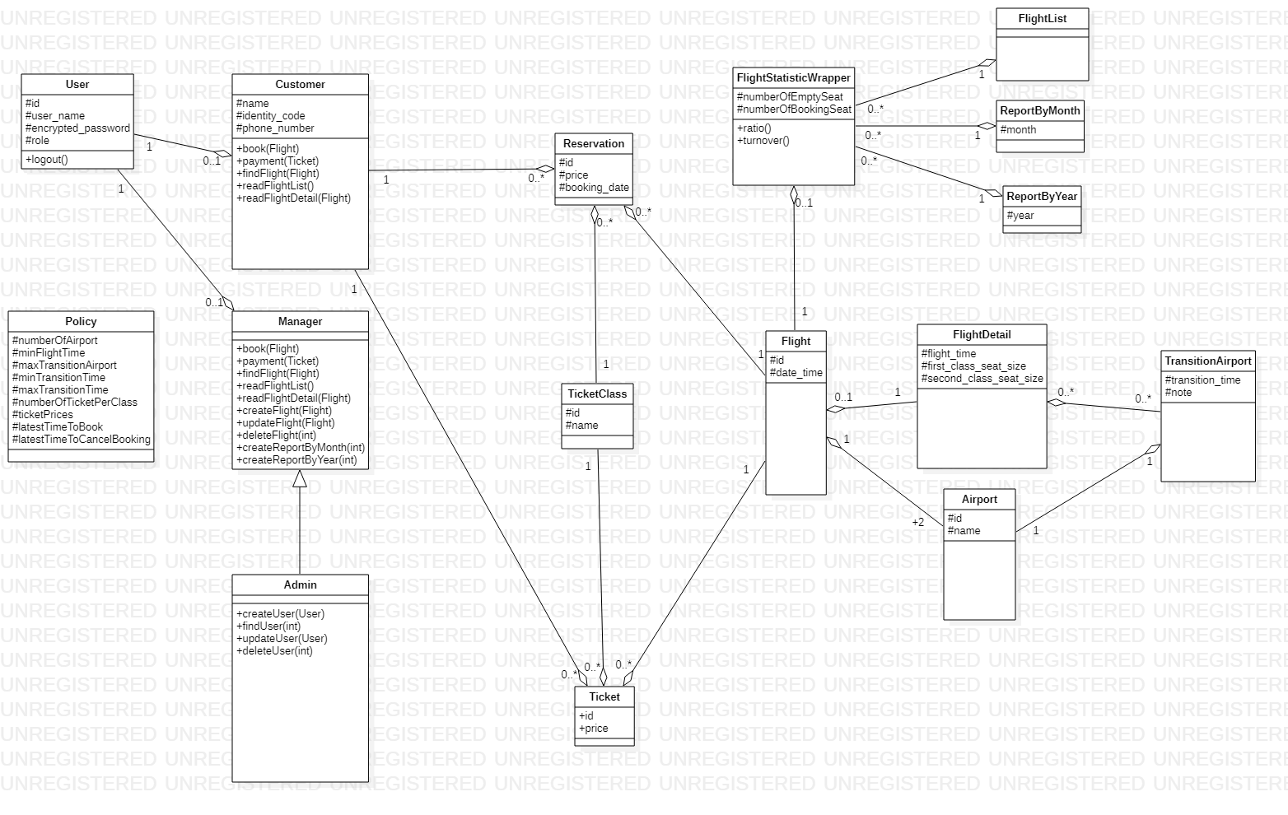

**Hình 2.18: Phiên bản first-cut class diagram**

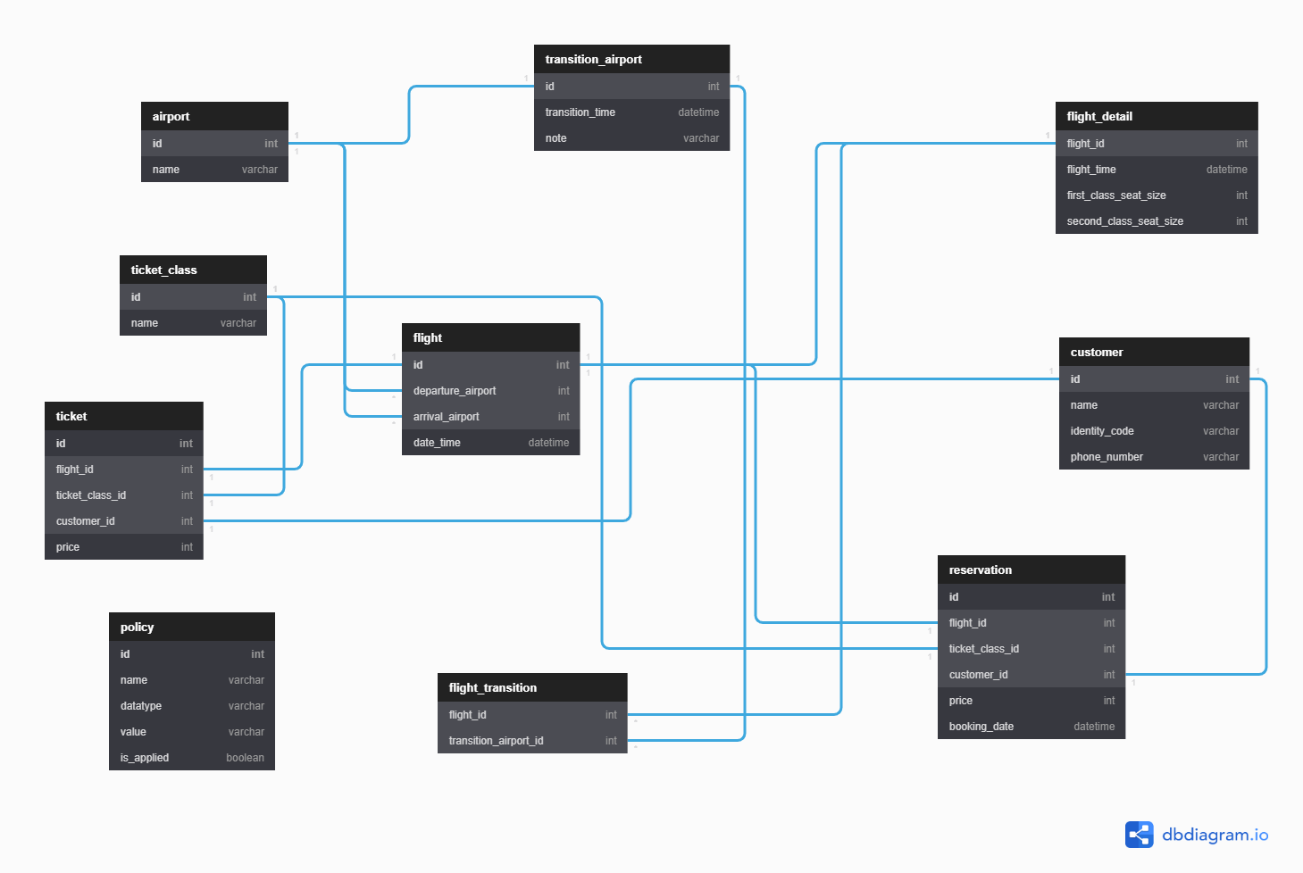

**Hình 2.19: Phiên bản first-cut ERD**

### 2.3.2 Conceptual ERD

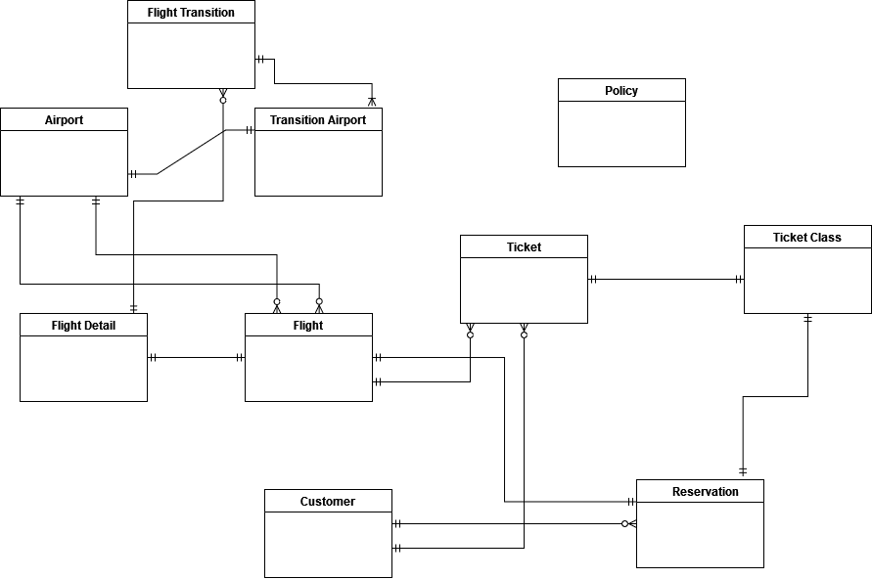

**Hình 2.20: Concept ERD**

### 2.3.3 Logical ERD

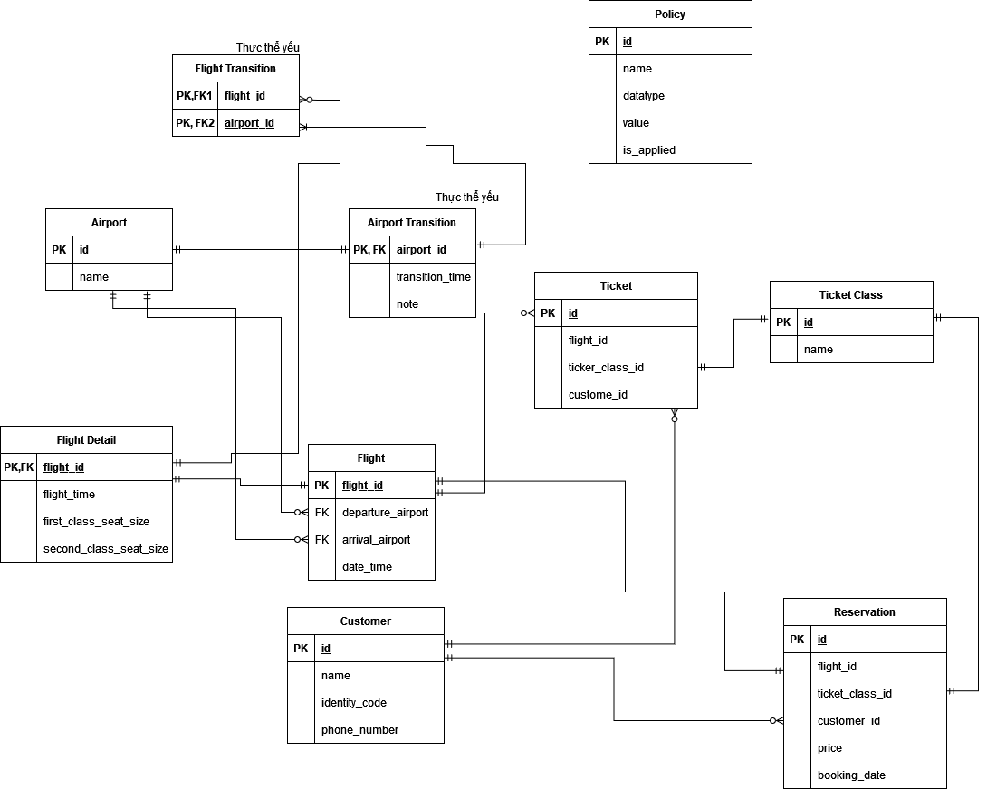

**Hình 2.21: Logical ERD**

## **2.4** **Architectural Analysis**

### 2.4.1 Analysis Architecture

#### 2.4.1.1 High Level Abstract Architecture - Level 0

**Hình 2.22: Kiến trúc tổng quát 3-Tier**

#### 2.4.1.2 High Level Abstract Architecture - Level 1

**Hình 2.23: Architecture cho data fault analysis system**

### 2.4.2 Analysis Package

#### 2.4.2.1 High Level Abstract Analysis Package - Level 0

**Hình 2.24: VC Structure ở mức Abstract level 0**

#### 2.4.2.2 High Level Abstract Analysis Package - Level 1

**Hình 2.25: MVC Structure ở mức Abstract level 1**

## **2.5** **VOPC Analysis**

### 2.5.1 Sequence Diagram for Booking Flight Use Case

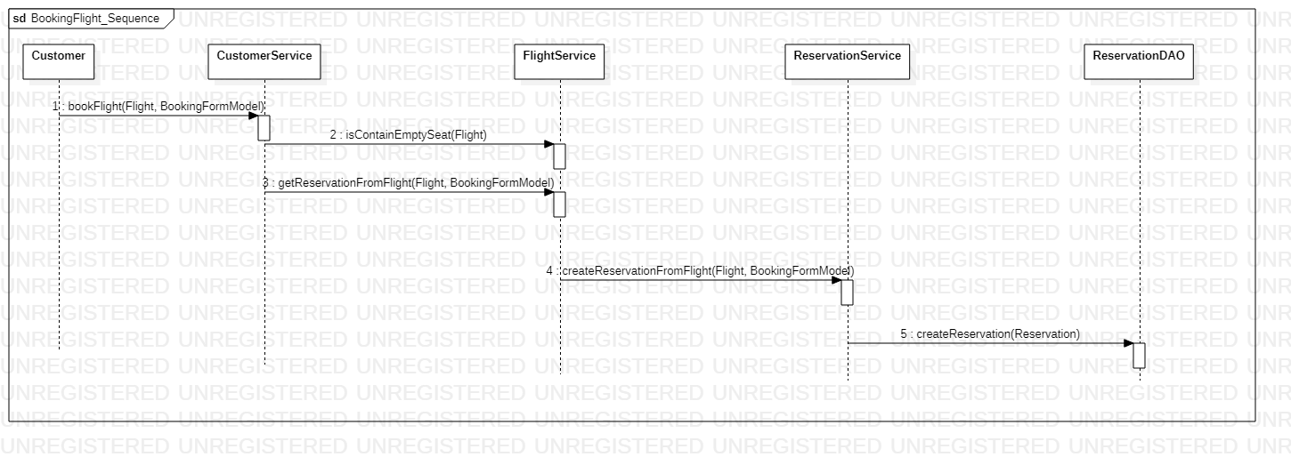

**Hình 2.26: Booking Flight sequence diagram**

#### 2.5.1.1 Analysis Class cho Booking Flight Use Case

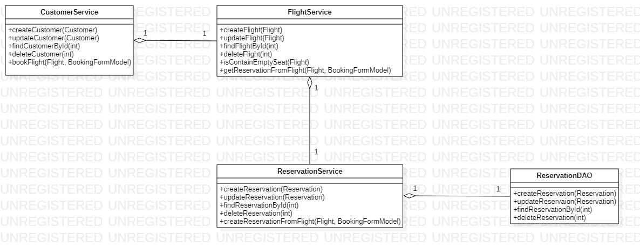

**Hình 2.27: Class Diagram cho Booking Flight Use Case**

#### 2.5.1.2 Analysis Package cho Booking Flight Use Case

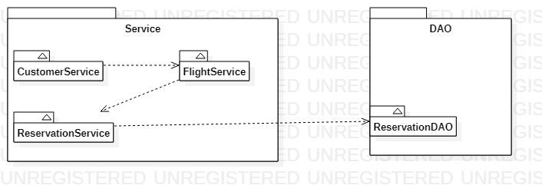

**Hình 2.28: Analysis Package cho Booking Flight Use Case**

### 2.5.2 Sequence Diagram for Create Flight Use Case

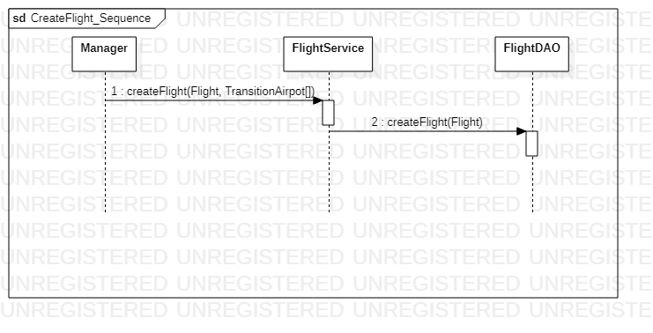

**Hình 2.29: Create Flight sequence diagram**

#### 2.5.2.1 Analysis Class cho Create Flight Use Case

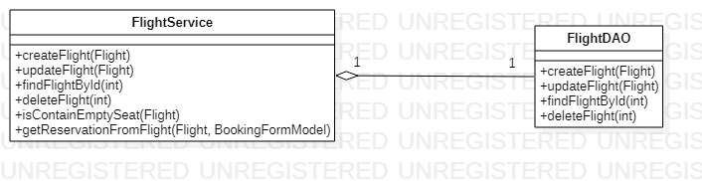

**Hình 2.30: Class Diagram cho Create Flight Use Case**

#### 2.5.2.2 Analysis Package cho Create Flight Use Case

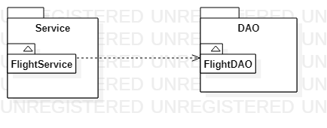

**Hình 2.31: Analysis Package cho Create Flight Use Case**

### 2.5.3 Sequence Diagram for Update Flight Use Case

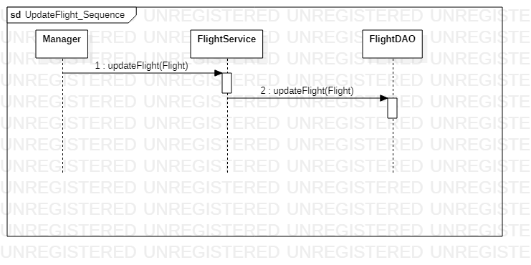

**Hình 2.32: Update Flight sequence diagram**

#### 2.5.3.1 Analysis Class cho Update Flight Use Case



**Hình 2.33: Class Diagram cho Update Flight Use Case**

#### 2.5.3.2 Analysis Package cho Update Flight Use Case



**Hình 2.34: Analysis Package cho Update Flight Use Case**

### 2.5.4 Sequence Diagram for Create Report

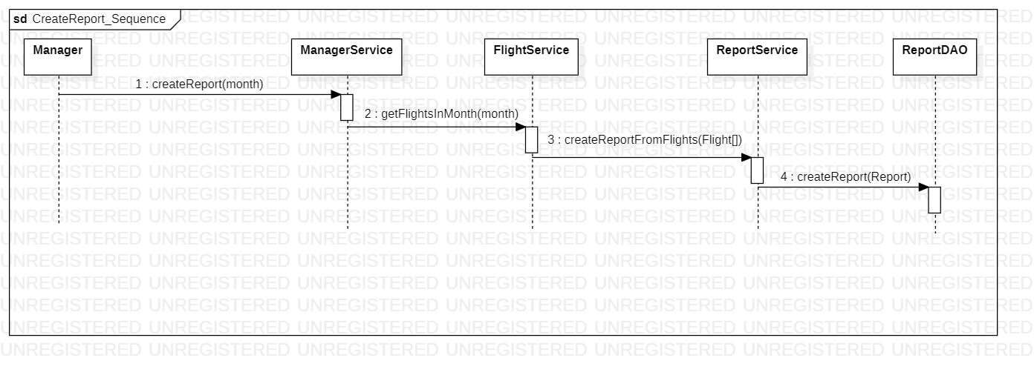

**Hình 2.35: Create Report sequence diagram**

#### 2.5.4.1 Analysis Class for Create Report

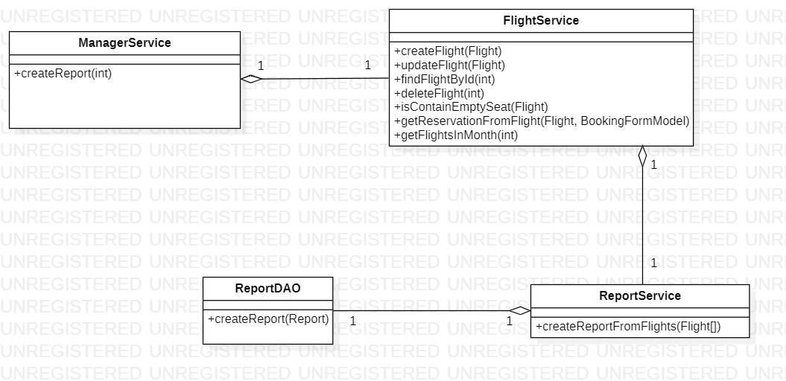

**Hình 2.36: Class Diagram cho Create Report Use Case**

#### 2.5.4.2 Analysis Package for Creating Report

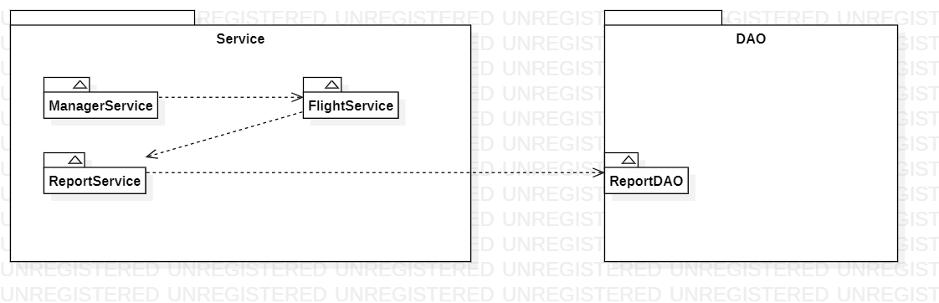

**Hình 2.37: Analysis Package cho Create Report Use Case**

### 2.5.5 Sequence Diagram for Create Account

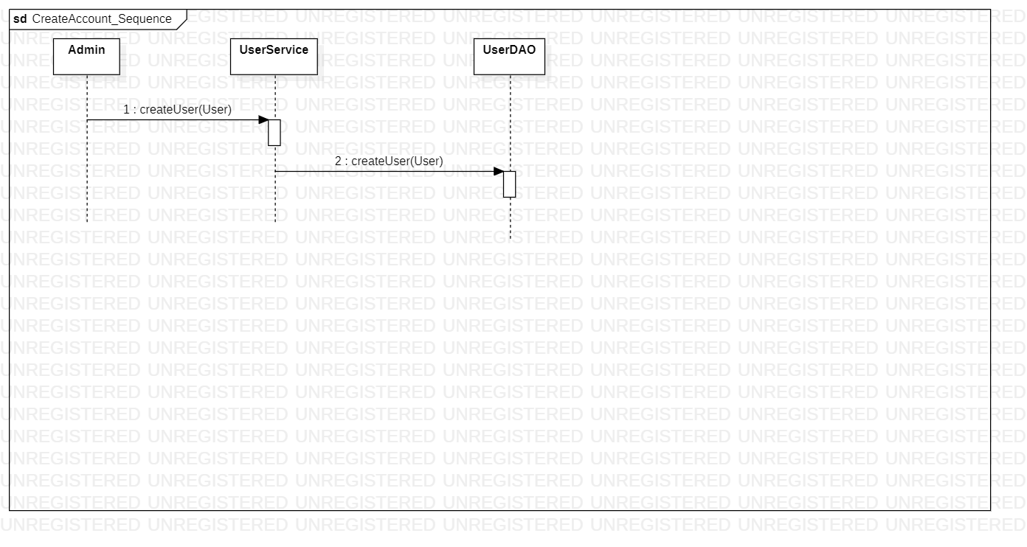

**Hình 2.38: Create Account sequence diagram**

#### 2.5.5.1 Analysis Class for Create Account

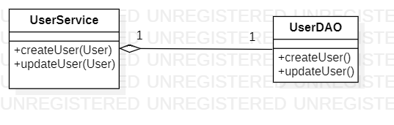

**Hình 2.39: Class Diagram cho Create Account Use Case**

#### 2.5.5.2 Analysis Package for Create Account

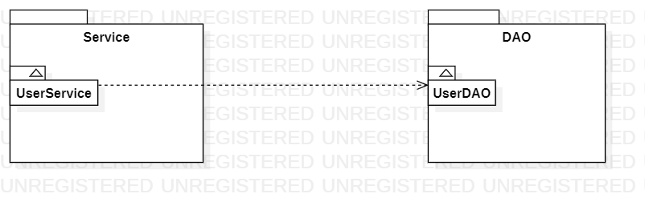

**Hình 2.40: Analysis Package cho Create Account Use Case**

### 2.5.6 Sequence Diagram for Update Account

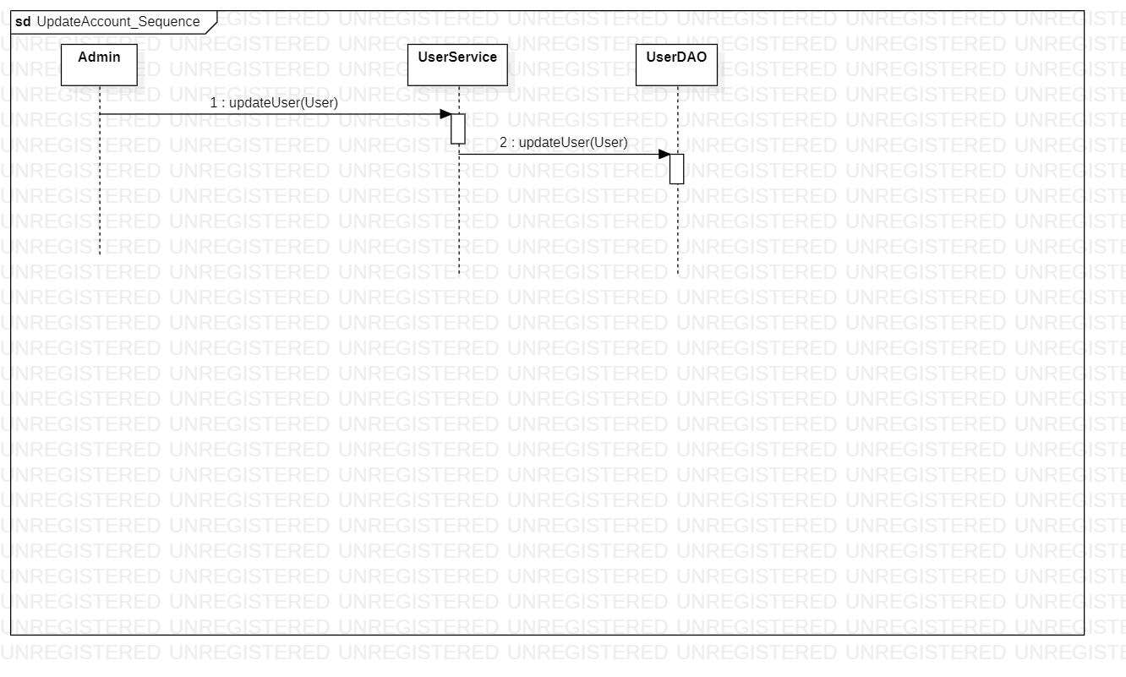

**Hình 2.41: Update Account sequence diagram**

#### 2.5.6.1 Analysis Class for Update Account



**Hình 2.42: Class Diagram cho Update Account Use Case**

#### 2.5.6.2 Analysis Package for Update Account

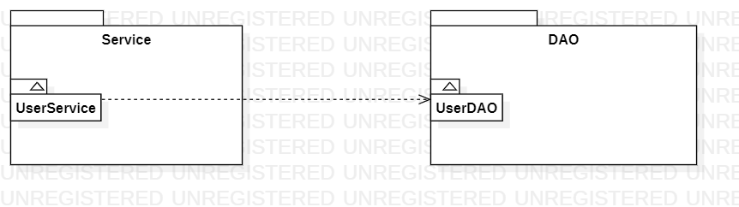

**Hình 2.43: Analysis Package cho Update Account Use Case**

### 2.5.7 Read Flight List

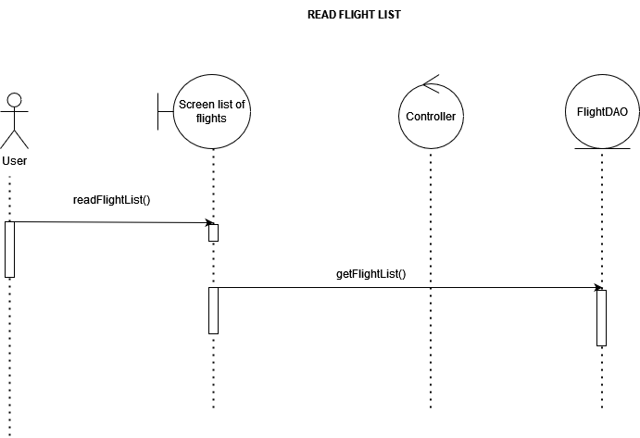

**Hình 2.44: Read Flight List sequence diagram**

#### 2.5.7.1 Analysis Class for Read Flight List

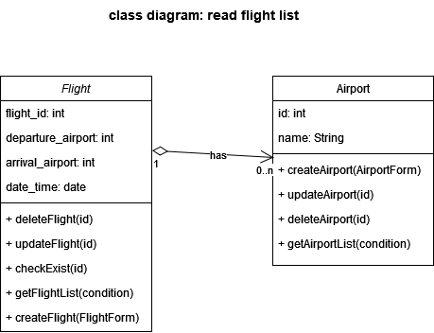

**Hình 2.45: Class Diagram cho Read Flight List Use Case**

#### 2.5.7.2 Analysis Package for Read Flight List

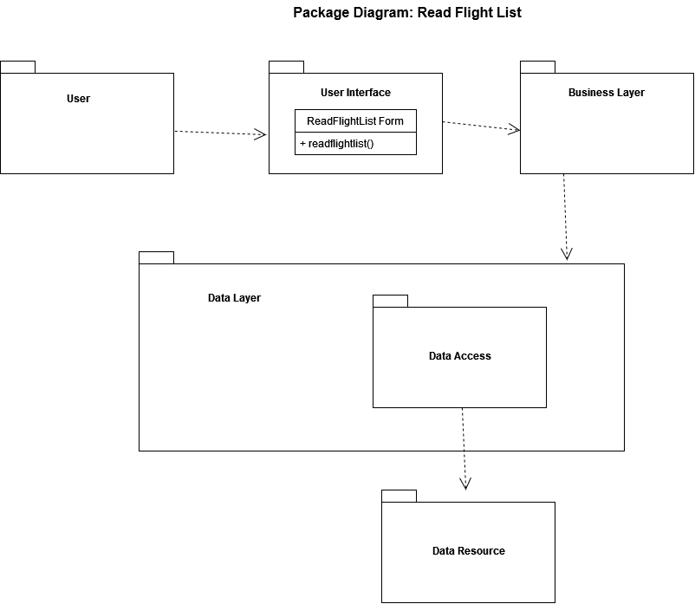

**Hình 2.46: Analysis Package cho Read Flight List Use Case**

### 2.5.8 Read Flight Detail

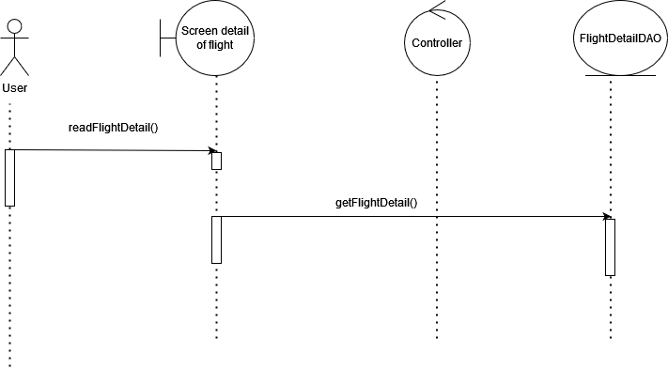

**Hình 2.47: Read Flight Detail sequence diagram**

#### 2.5.8.1 Class dỉagram for Read Flight Detail

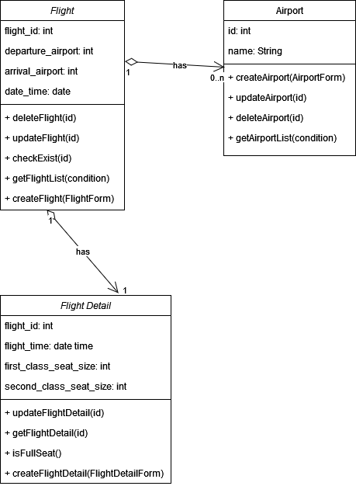

**Hình 2.48: Class Diagram cho Read Flight Detail Use Case**

#### 2.5.8.2 Package diagram for Read Flight Detail

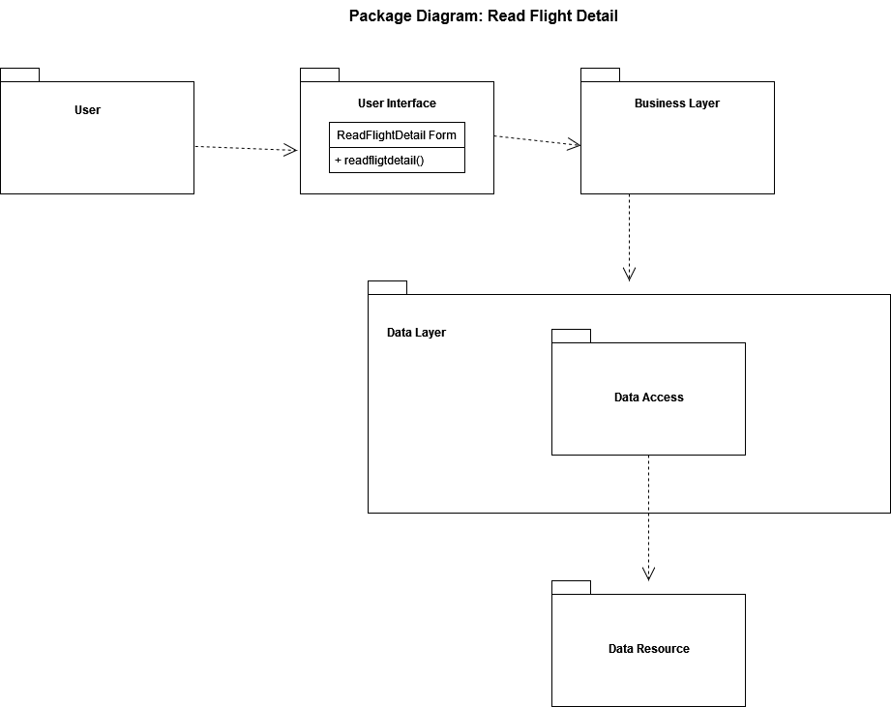

**Hình 2.49: Analysis Package cho Read Flight Detail Use Case**

### 2.5.9 Sequence Diagram for Read Account List

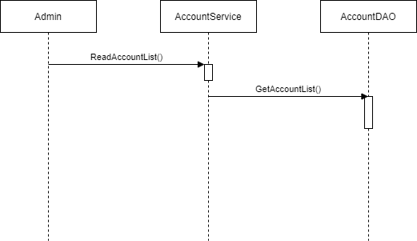

**Hình 2.50: Read Account List sequence diagram**

#### 2.5.9.1 Analysis Class for Read Account List

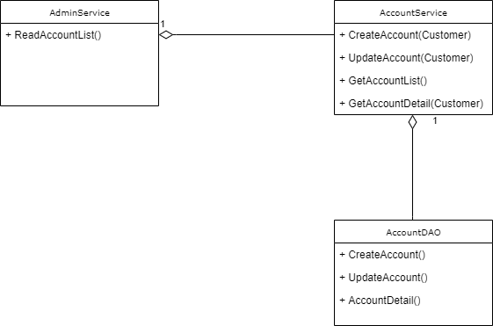

**Hình 2.51: Analysis Class cho Read Account List Use Case**

#### 2.5.9.2 Analysis Package for Read Account List

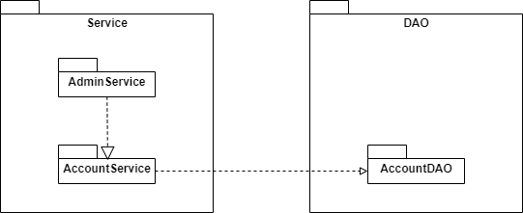

**Hình 2.52: Analysis Package cho Read Account List Use Case**

### 2.5.10 Sequence Diagram for Read Account Detail

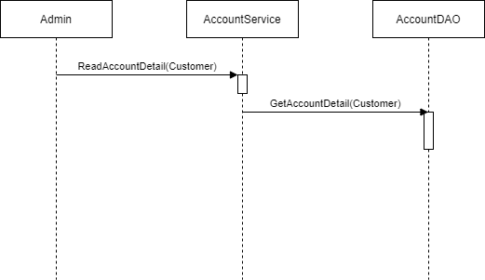

**Hình 2.53: Read Account Detail sequence diagram**

#### 2.5.10.1 Analysis Class for Read Account Detail

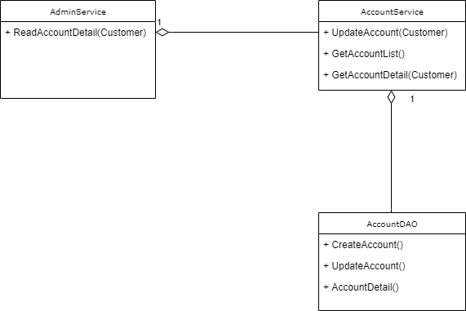

**Hình 2.54: Analysis Class cho Read Account Detail Use Case**

#### 2.5.10.2 Analysis Package for Read Account Detail



**Hình 2.55: Analysis Package cho Read Account Detail Use Case**

### 2.5.11 Sequence Diagram for Login

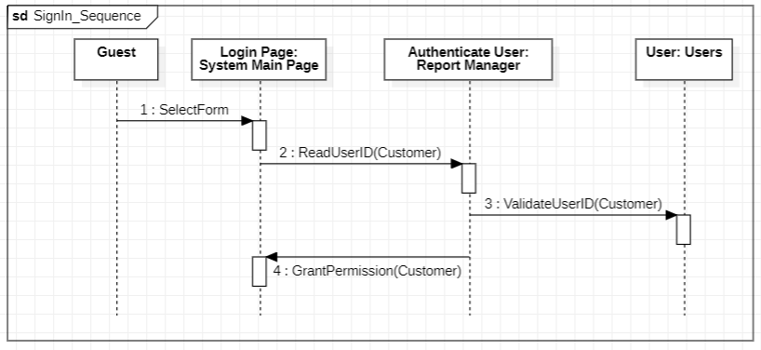

**Hình 2.56: Login sequence diagram**

#### 2.5.11.1 Analysis Class for Login

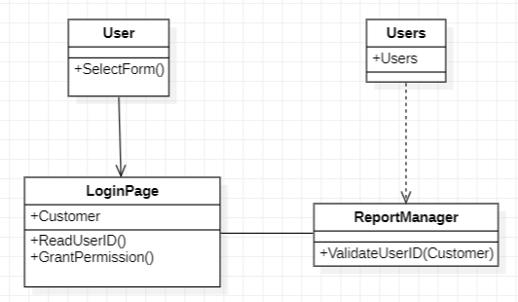

**Hình 2.57: Analysis Class cho Login Use Case**

#### 2.5.11.2 Analysis Package for Login

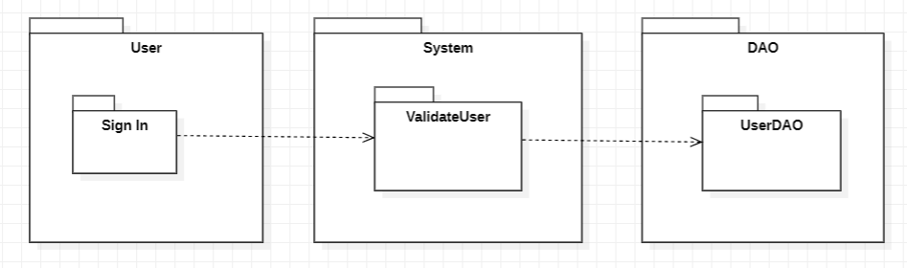

**Hình 2.58: Analysis Package cho Login Use Case**

### 2.5.12 Sign Up Sequence Diagram

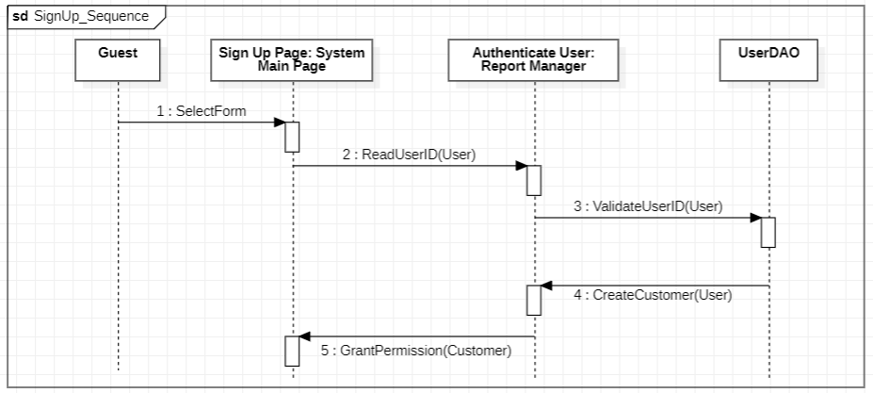

**Hình 2.59: Sign Up sequence diagram**

#### 2.5.12.1 Analysis Class for Sign Up

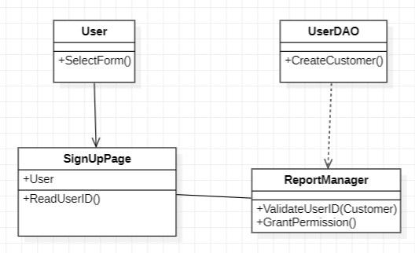

**Hình 2.60: Analysis Class cho Sign Up Use Case**

#### 2.5.12.2 Analysis Package for Sign Up

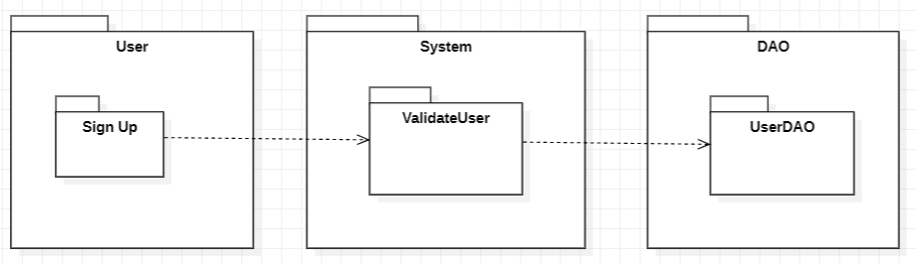

**Hình 2.61: Analysis Package cho Sign Up Use Case**

## **2.6** **4 + 1 Architectural View Modeling in Analysis Level**

### 2.6.1 Process / Behavior View

#### 2.6.1.1 Sequence Diagram



**Hình 2.62: Sequence Diagram for Booking Flight**



**Hình 2.63: Sequence Diagram for Create Flight**



**Hình 2.64: Sequence Diagram for Update Flight**



**Hình 2.65: Sequence Diagram for Create Report**



**Hình 2.66: Sequence Diagram for Create Account**



**Hình 2.67: Sequence Diagram for Update Account**



**Hình 2.68: Sequence Diagram for Read Flight List**



**Hình 2.69: Sequence Diagram for Read Flight Detail**



**Hình 2.70: Sequence Diagram for Read Account List**

**Hình 2.71: Sequence Diagram for Read Account Detail**



**Hình 2.72: Sequence Diagram for Login**



**Hình 2.73: Sequence Diagram for Sign Up**

### 2.6.2 Implementation / Developer View

#### 2.6.2.1 Package Diagram

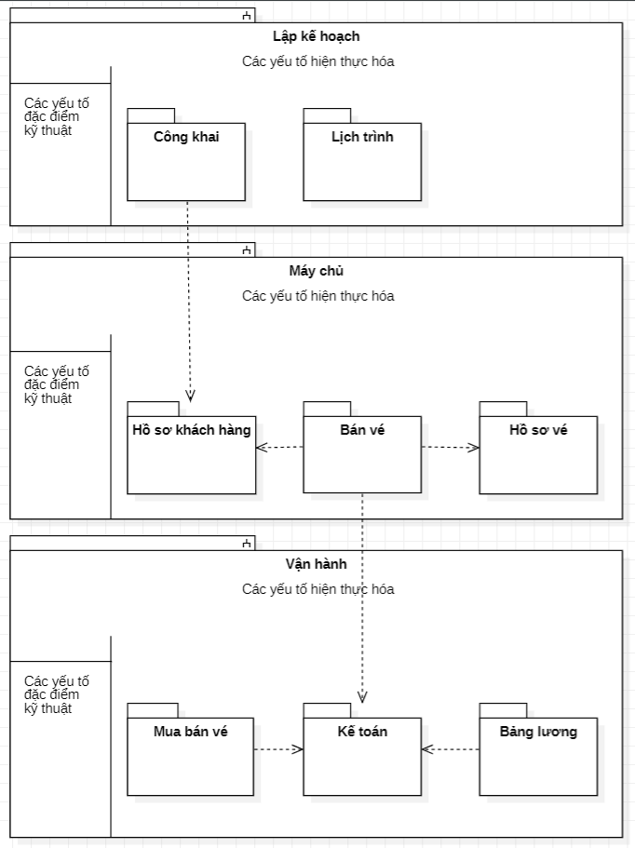

**Hình 2.74: Package Diagram**

### 2.6.3 Logical / Structural View

#### 2.6.3.1 Class Diagram

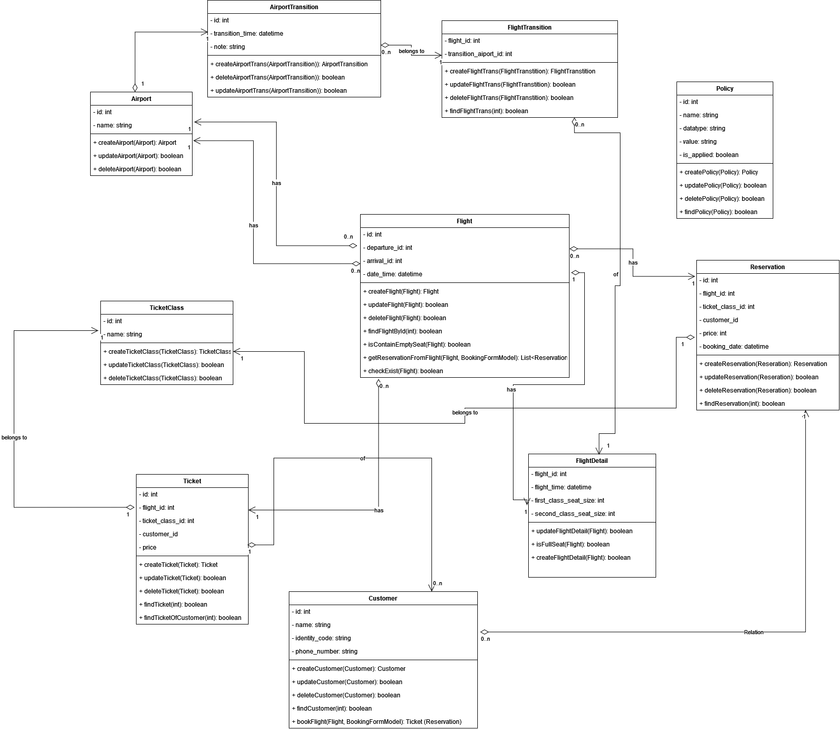

**Hình 2.75: Class Diagram**

### 2.6.4 Deployment / Physical View

#### 2.6.4.1 Deployment Diagram

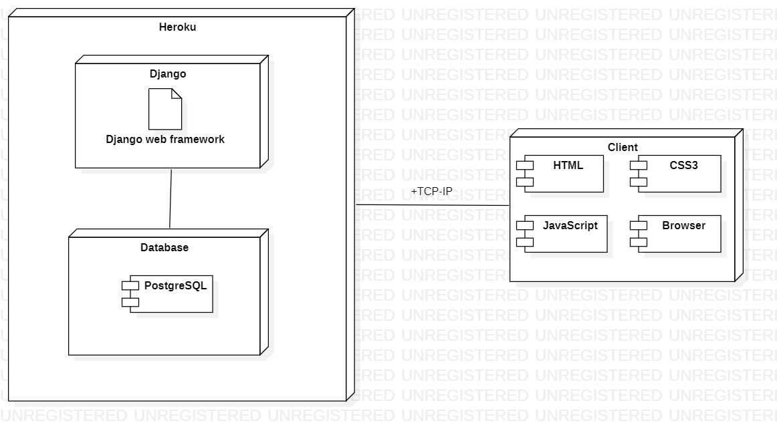

**Hình 2.76: Deployment Diagram**